PHYSICS-1401 LAB KIT

For those of you who have taken the Lab Kit for Physics-1 from HCC, you should now do the following:

After you take the equipment home:
- Open the Box, and make sure all listed equipment is in it. You already have the list of equipment, and a copy of that list is also attached below. At the bottom of this file are pictures of each of these items for you to compare with what you have in the two boxes that you received.
- Each item of equipment has a description, and a manual on how to use it. Read these carefully, as you will be assembling / setting up the equipment on your own.
- After checking the equipment, carefully put it back. Use the two boxes as storage. You will need these to return the equipment in the week of June 05, 2021.
- We will use “Capstone” as the software to collect data from the smart instruments. Install Capstone software on your computer/Laptop by using the link: www.pasco.com/downloads/capstone
Download the Trial Version, which is initially good for 60 days.
- During the Lab session on Thursday June 10, I will show you how to assemble the track, and how to use the Capstone Software, and how to link the smart instruments to Capstone. This information is also available in Canvas in “LAB KIT INFORMATION”

Before each Online Lab Session starts:
- Study the Lab Manual.
- Solve the Pre-Lab Quiz on Canvas. This is due before 5:00 pm.

During the Online Lab Sessions, we plan to use the following procedure:
- Take out the required equipment (as mentioned in the Lab Manual).
- The Instructor will describe how to assemble the equipment, perform the experiment and analyze the data. I will do this with my camera on, showing you the equipment. You can also assemble/setup the equipment at the same time.
- Open your camera to show the equipment setup to Instructor.
- Once the equipment seems to be set up correctly, start performing the experiment and take the data. You will need to briefly show me on camera how you are doing the experiment (5 points for this). Take a few pictures of the setup (5 points for that).
- Complete the Analysis of the data.
- Do the Post-Lab Quiz in Canvas.
- Carefully put the equipment back in their bags and then into the box.

After the Lab session is over:
- Write the Lab Report and upload it as a doc file in canvas by the next day. Paste the pictures of your setup in the report.
- You can also upload a video of the Lab being performed (this is 5 points extra credit). There is a place in the Lab modules in canvas where you can do this.

LIST OF EQUIPMENT IN PHYSICS-1 LAB KIT

 | Item | Description | Qty
1 | ME-5717A  Includes: | Standard Smart Cart/ PASTrack System | 1
 | 012-16827 | INST MNL, ME-5717A | 1
 | ME-1240 | Smart Cart (Red) | 1
 | ME-1241 | Smart Cart (Blue) | 1
 | ME-1244 | Smart Cart Rod Stand Adapter | 1
 | ME-6757A | Cart Mass (set of 2) | 1
 | ME-6960 | PAStrack | 1
 | ME-8971 | Dynamic Track End Stop 2 Pack | 1
 | ME-8999 | IDS Spring Kit | 1
 | ME-9448B | Super Pulley with Clamp | 1
 | ME-9495A | Angle Indicator | 1
 | ME-9807 | Friction Block -- IDS | 1
 | ME-9836 | Track Rod Clamp | 1
2 | 699-011 | NYLON THREAD | 1
3 | ME-8979 | PASCO Mass & Hanger St | 1
4 | PS-3225 | Wireless Smart Gate | 1
5 | ME-8569A | Density Set | 1
6 | 648-10344 | ROD, SUPER PULLEY | 1
7 | ME-8976 | Small A-Base | 1
8 | ME-8736 | 45 cm Stainless Steel Rod | 1
9 | SE-8827 | Meter Stick | 1
10 | ME-9377A | Picket Fence | 1
11 | ME-9507 | Multi-Clamp | 1
12 | 740-162 | BOX PLST 18.1X12.3X7.5 18 QT CLR SNAPLOCK | 1

EQUIPMENT IN PHYSICS-1 LAB KIT

Item - 1
ME-1240 Smart Cart – Red  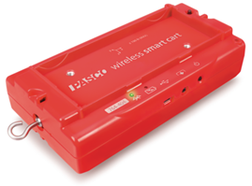 |  | ME-1241 Smart Cart – Blue  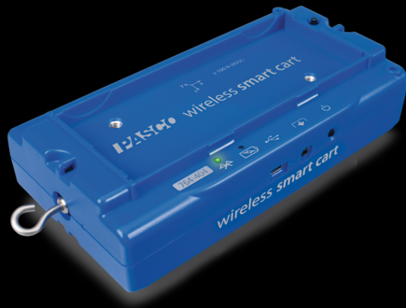
ME-1244 Smart Cart Rod Stand Adapter  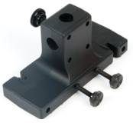 |  | ME-6757A Cart Mass (set of 2)  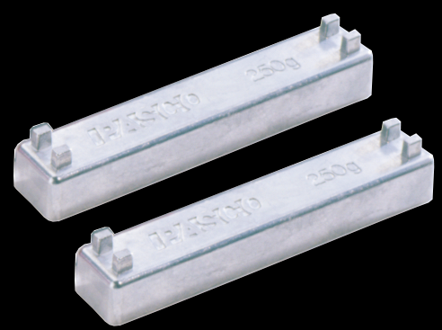
ME-6960 PAStrack  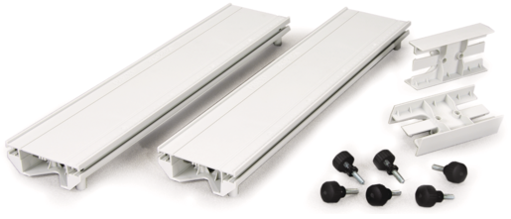 |  | ME-8971 Dyn Track End Stop 2 Pk  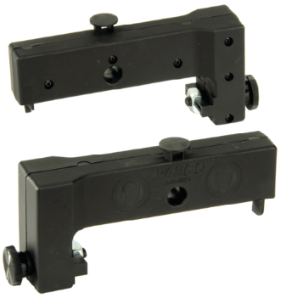
ME-8999 IDS Spring Kit  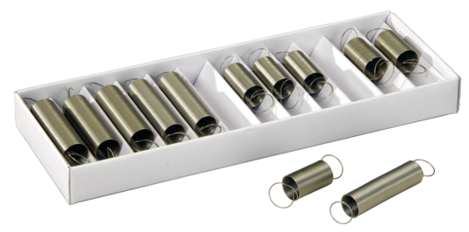 |  | ME-9448B Super Pulley with Clamp  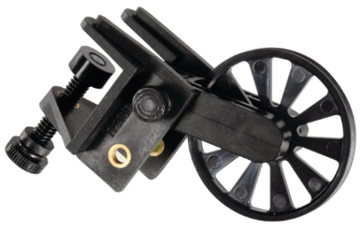
ME-9495A Angle Indicator  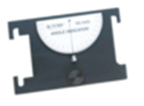 |  | ME-9807 Friction Block – IDS  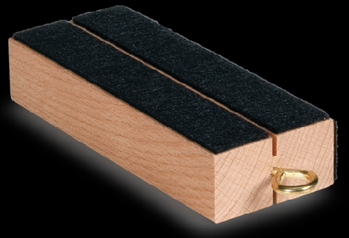
ME-9836 Track Rod Clamp

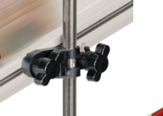

2- 699-011 Nylon Thread  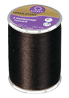 |  | 3- ME-8979 PASCO Mass & Hanger St  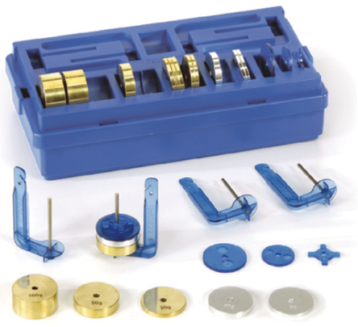
4- PS-3225 Wireless Smart Gate  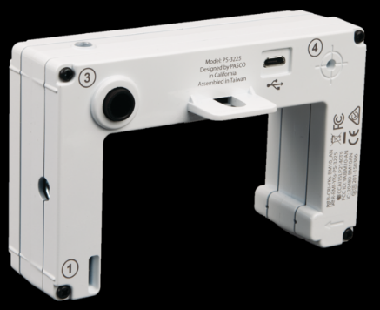 |  | 5- ME-8569A Density Set  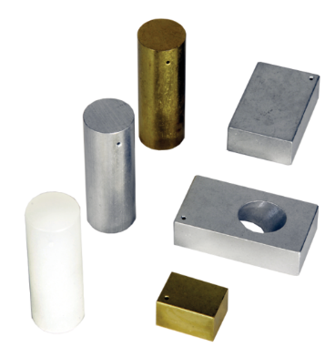
6- 648-10344 Rod, Super pulley  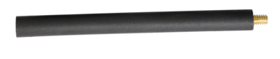 |  | 7- ME-8976 Small A-Base  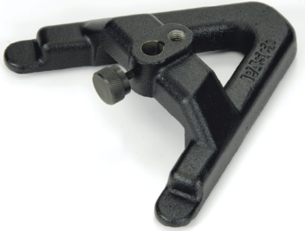
8- ME-8736 45 cm Stainless Steel Rod |  | 9- SE-8827 Meter Stick  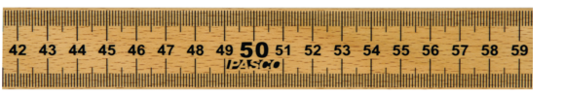
10- ME-9377A Picket Fence   |  | 11- ME-9507 Multi-Clamp  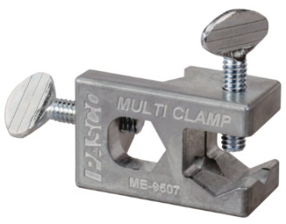
12- 740-162 Box PLST
Plastic Container

